Problem 3

**a)** Below is the script ‘Lab2_q3_fs_func1.m’ written to compute the Fourier series and to plot the partial sums for function 1

Lab2_q3_fs_func1.m

%Ecem Kahraman, 47962113

%Kurtis Harms, 38764114

%Mike Wilk, 21085121

%Purpose: Computing the Fourier series for the first function f(x)=abs(x)

%for x=[-2,2] and plotting the partial sums

clear all

format long

color=['r','b','m','g']

x=linspace(-2,2,200)

%N values given for finding the first N nonzero terms of this series

N=[5 10 30 100]

%a_0 value found analytically = 1

a_0=1;

for j = 1:length(N)

partialsum=0;

%Even function so no b_n terms

for n=1:N(j)

partialsum=partialsum+((-8/((pi*n).^2)).*cos((n*pi*x)/2));

end

%Finding the total partial sum with a_0 value added

SN=partialsum+a_0;

hold on

plot(x,SN,color(j),'Linewidth',2)

title('Plot of the Nth partial sums for the first function')

xlabel('x')

ylabel('SN(x)')

legend('N=5','N=10','N=30', 'N=100')

end

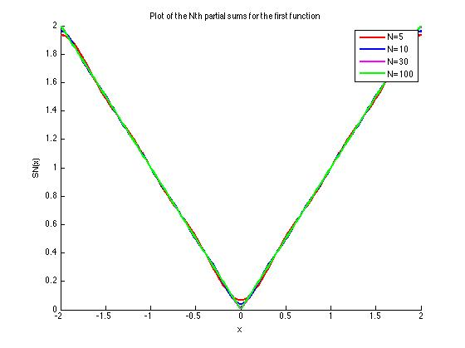

Below is the script ‘Lab2_q3_fs_func2.m’ written to compute the Fourier series and to plot the partial sums for function 2

Lab2_q3_fs_func2.m

%Ecem Kahraman, 47962113

%Kurtis Harms, 38764114

%Mike Wilk, 21085121

%Purpose: Computing the Fourier series for the second function

%for x=[-2,2] and plotting the partial sums

clear all

format long

color=['r','b','m','g']

x=linspace(-2,2,200)

%N values given for finding the first N nonzero terms of this series

N=[5 10 30 100]

for j=1:length(N)

partialsum=0;

%Odd function thus no a_n terms

for n=1:2:N(j)

partialsum=partialsum+((4/(pi*n))*sin((n*pi*x)/2));

end

%a_0=0; thus SN=partial sum found above

SN=partialsum;

hold on

plot(x,SN,color(j),'Linewidth',2)

title('Plot of the Nth partial sums for the second function')

xlabel('x')

ylabel('SN(x)')

legend('N=5','N=10','N=30', 'N=100')

end

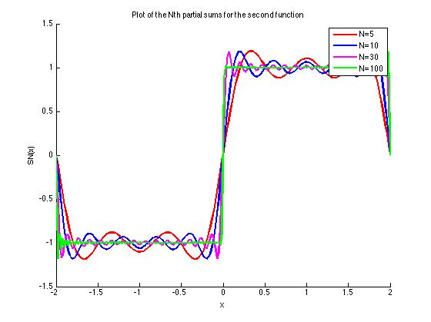

Below is the script ‘Lab2_q3_abserror_f1.m’ written to compute and plot the error in Fourier series for the first function and to compute the relative error at x=1/2

Lab2_q3_abserror_f1.m

%Ecem Kahraman, 47962113

%Kurtis Harms, 38764114

%Mike Wilk, 21085121

%Purpose: Computing and plotting the error in Fourier series for the first function f(x)=abs(x) for x=[-2,2] and to compute the relative %error at x=1/2

clear all

format long

color=['r','b','m','g']

x=linspace(-2,2,200);

%Since there is no exact x=0.5 in our x values, we aim to get the one

%closest to 0.5 and the index value for this x is found below

ind=find(abs(x-0.5)<0.01);

%N values given for finding the first N nonzero terms of this series

N=[5 10 30 100]

%a_0 value found analytically = 1

a_0=1;

for j = 1:length(N)

partialsum=0;

%Even function so no b_n terms

for n=1:2:N(j)

partialsum=partialsum+((-8/((pi*n).^2))*cos((n*pi*x)/2));

end

%Finding the total partial sum with a_0 value added

SN=partialsum+a_0;

F1=abs(x);

abserr=abs(SN-F1);

%value of SN(0.5) and relative error at x=0.5

val(j)=SN(ind);

relerr(j)=abs(abs(x(ind))-val(j))/abs(x(ind));

plot(x,abserr,color(j),'Linewidth',2)

title('Absolute error in Nth partial sum of Fourier series for the first function',’fontsize’,13)

xlabel('x')

ylabel('Absolute error')

legend('N=5','N=10','N=30', 'N=100')

hold on

end

Below is the script ‘Lab2_q3_abserror_f2.m’ written to compute and plot the error in Fourier series for the first function and to compute the relative error at x=1/2

Lab2_q3_abserror_f2.m

%Ecem Kahraman, 47962113

%Kurtis Harms, 38764114

%Mike Wilk, 21085121

%Purpose: Computing and plotting the error in Fourier series for the

%second function and to compute the relative error at x=1/2

clear all

format long

color=['r','b','m','g']

x=linspace(-2,2,200)

%Since there is no exact x=0.5 in our x values, we aim to get the one

%closest to 0.5 and the index value for this x is found below

ind=find(abs(x-0.5)<0.01);

%N values given for finding the first N nonzero terms of this series

N=[5 10 30 100]

for j=1:length(N)

partialsum=0;

%Odd function thus no a_n terms

for n=1:2:N(j)

partialsum=partialsum+((4/(pi*n)).*sin((n*pi*x)/2));

end

%a_0=0; thus SN=partial sum found above

SN=partialsum;

%defining the actual function F2

F2=zeros(1,length(x));

for k=1:length(x)

if x(k)>0;

F2(k)=1;

else

F2(k)=-1;

end

end

abserr=abs(SN-F2);

%value of SN(0.5) and relative error at x=0.5

val(j)=SN(ind);

relerr(j)=abs(1-val(j))/1;

plot(x,abserr,color(j),'Linewidth',2)

title('Absolute error in Nth partial sum of Fourier series for the second function',’fontsize’,13)

xlabel('x')

ylabel('Absolute error')

legend('N=5','N=10','N=30', 'N=100')

hold on

end

**b)** Below is the tabulated version of the values found for the value of the series at x=1/2, relative error and the significant figures SN (0.5) is correct to for different values of N. Since there was no exact x=0.5 in our array, the nearest value was found to be 0.49246 and the evaluation was done at this point.

*Function 1*

|  |  |  |  |
| --- | --- | --- | --- |
| **N** | **SN (0.5)** | **Relative error in SN (0.5)** | **Number of significant figures SN (0.5) is correct to** |
| 5 | 0.5057200876 | 0.0269214024 | 2 |
| 10 | 0.4872429676 | 0.0105984638 | 2 |
| 30 | 0.4930456325 | 0.0011844987 | 3 |
| 100 | 0.4924081925 | 0.0001098949 | 4 |

*Function 2*

|  |  |  |  |
| --- | --- | --- | --- |
| **N** | **SN (0.5)** | **Relative error in SN (0.5)** | **Number of significant figures SN (0.5) is correct to** |
| 5 | 1.0310732109 | 0.0310732109 | 2 |
| 10 | 0.9810783706 | 0.0189216294 | 2 |
| 30 | 1.0114875484 | 0.0114875484 | 2 |
| 100 | 1.0033496201 | 0.0033496202 | 3 |

**c)** Below is the figure obtained using ‘Lab2_q3_abserror_f1.m’

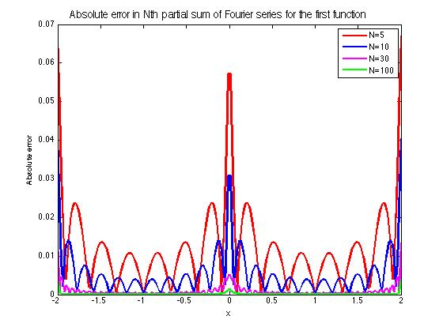

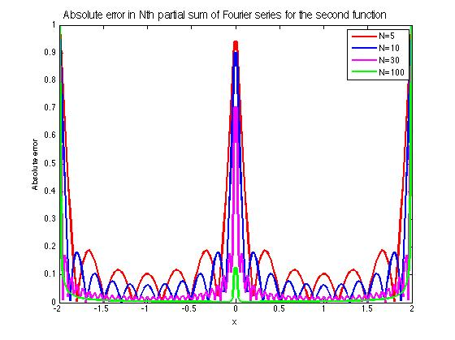Below is the figure obtained using ‘Lab2_q3_abserror_f2.m’

As can be seen from the plots above, the maximum error is found at the boundaries (x=-2 and x=2) where the functions are extended periodically, and at discontinuities (x=0) for both function 1 and 2. When we look at the plots of absolute errors for both functions, we can see that with increasing N, absolute error decreases quite a lot for function 1; yet for function 2 not much change is observed where the maximums are observed (especially at boundaries) but in general, absolute error does decrease with increasing N. Since for part b, x=0.5 was of concern and it isn't very obvious from the plot above which N gives the highest/lowest error, the plot was zoomed in at that point. (See the figure below). Looking at the plot, it was observed that around x=0.51, N=5 gives the lowest absolute error and the general behaviour isn’t followed.

